**Creating Fields For Items Object**

**Creating Fields for Items object:**

1)While still on your salesforce account, navigate to the gear icon present in the top right    corner. You will notice Setup and click on setup.

2)You will now be navigated to the setup page, and click on object manager and search for object “Items”.

3)Click on “Fields & Relationships” in the left panel.

4) Click on New and choose the data type ( that is required by the field you need).

5) Click next and fill the following details in the mentioned.

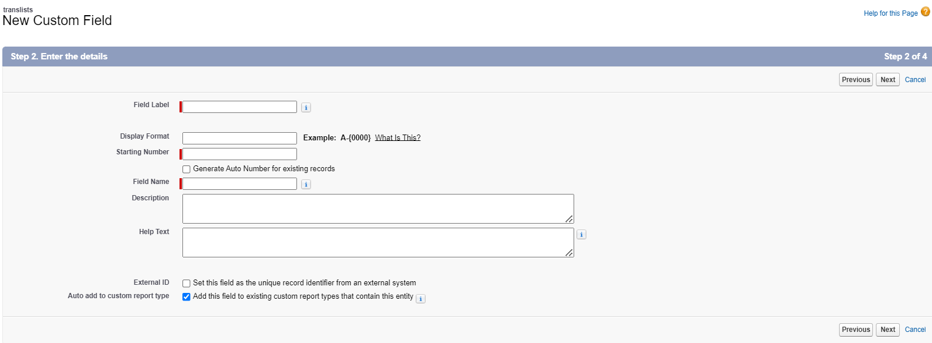

6) Click Next, Next and click on “Save and New”.

**Note :** Follow the above steps to create the fields prodname, prodid, price, manfdate.

| **S No** | **Field Label** | **Data Type** |
| --- | --- | --- |
| 1 | price | Number |
| 2 | manfdate | Date |
| 3 | prodname | Text |